Navigate to https://killercoda.com/login
After sign in go to
https://killercoda.com/playgrounds/scenario/kubernetes

1- How many pods exist on the system?

kubectl get pods

2- How many Nodes exist on the system?

kubectl get nodes

3- Create a new pod with the nginx image.
Image name: nginx
step 1:
create yaml file file.yaml and put into it the following :

apiVersion: v1
kind: Pod
metadata:
name: nginx
spec:
containers:
- name: nginx
image: nginx:1.14.2
ports:
- containerPort: 80



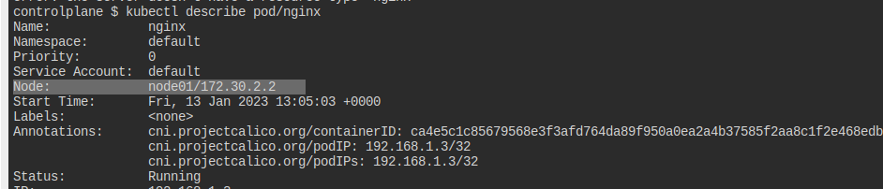
4- Which nodes are these pods placed on?

5- Create pod from the below yaml using kubectl apply command

apiVersion: v1
kind: Pod
metadata:
name: webapp
namespace: default
spec:
containers:
- image: nginx
imagePullPolicy: Always
name: nginx
- image: agentx
imagePullPolicy: Always
name: agentx

6- How many containers are part of the pod webapp
2 containers

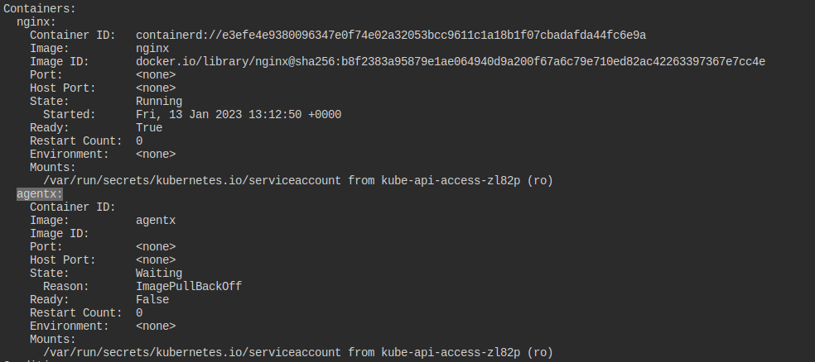

7- What images are used in the new webapp pod?

2 images
8- What is the state of the container agentx in the pod webapp

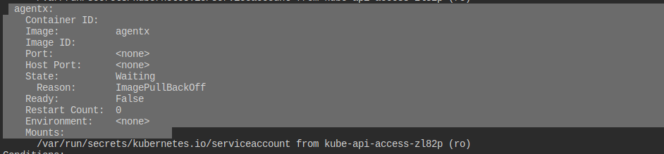

9- Why do you think the container agentx in pod webapp is in error?

Because image is in valid, (image pull back off)

10- Delete the webapp Pod.

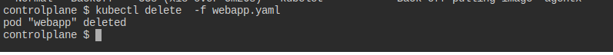
kubectl delete -f webapp.yaml

11- Create a new pod with the name redis and with the image redis123.
- Name: redis
- Image Name: redis123

yaml file:

apiVersion: v1
kind: Pod
metadata:
name: redis
spec:
containers:
- name: redis
image: redis123

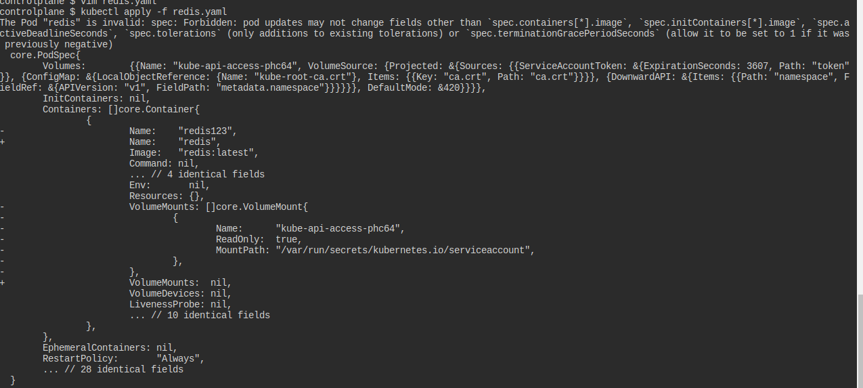

12- Now change the image on this pod to redis.
Once done, the pod should be in a running state.

yaml file:

apiVersion: v1
kind: Pod
metadata:
name: redis
spec:
containers:
- name: redis123
image: redis:latest

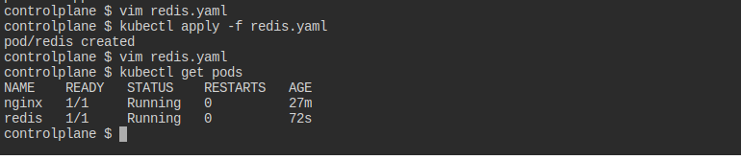

13- Create a pod called my-pod of image nginx:alpine

apiVersion: v1
kind: Pod
metadata:
name: mypod
spec:
containers:
- name: nginxalpine
image: nginx:alpine
ports:
- containerPort: 80

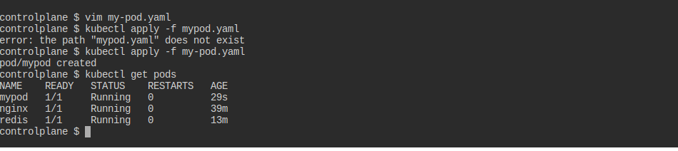

14- Delete the pod called my-pod

